**NETWORKING & SYSTEM ADMINISTRATION LAB**

**Name: ATHIRA BIJU**

**Roll No:4**

**Batch:S2 RMCA**

**Date:05/05/22**

**Experiment No.:**

**Aim**

Cmake

**Procedure &Output Screenshot**

APT SHOW CMAKE

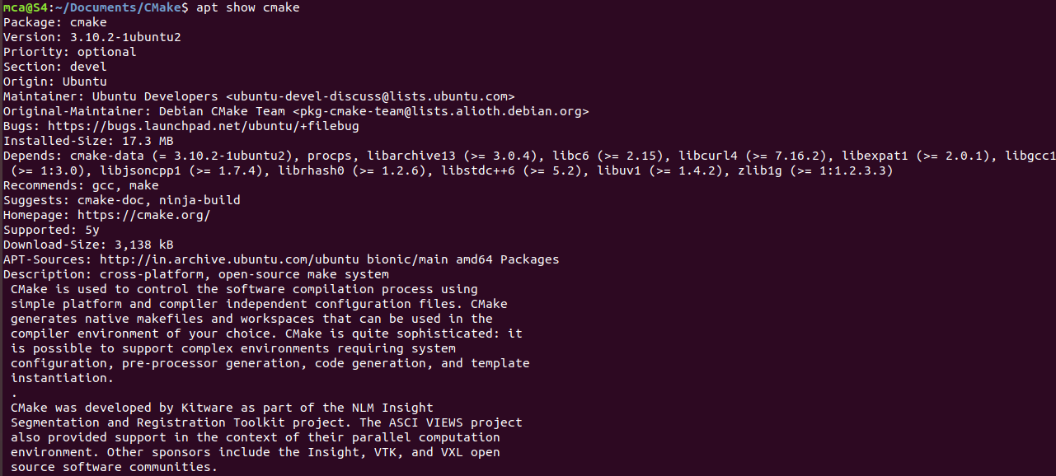

Sudo apt install cmake g++ make: **To install cmake , g++ and make using the apt command**

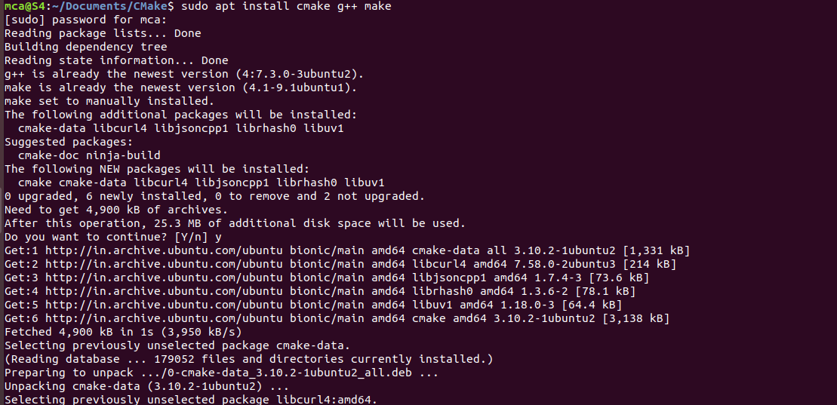

Mkdirmyproject**:** creating a different directory for our project using the [mkdir](https://www.linuxfordevices.com/tutorials/linux/the-mkdir-command-in-linux) and [cd](https://www.linuxfordevices.com/tutorials/linux/cd-command-in-linux) commands.



Now create a C++ source file named Hello_world.cpp and add the following



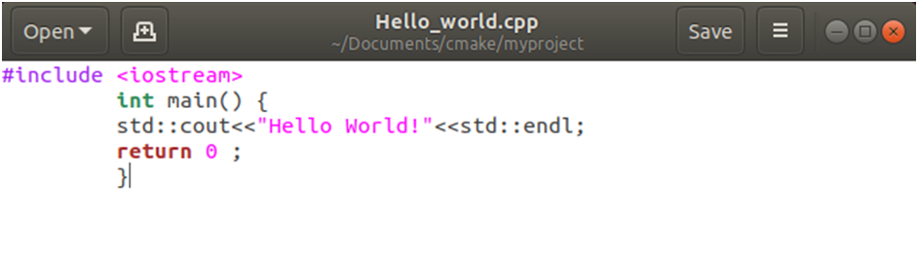

Gedit CMakeList.txt: Create a CMakeLists.txt file(with this exact capitalization) which is required by CMake:

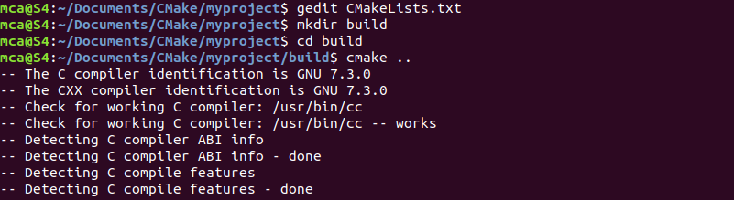

The CMakeLists.txt file for this project will only contain these three lines:

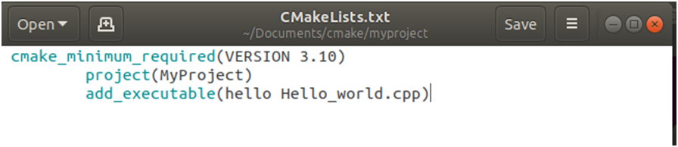

Mkdir build:Build directory for executables :



Cmake –build : generate the executable simply by typing:

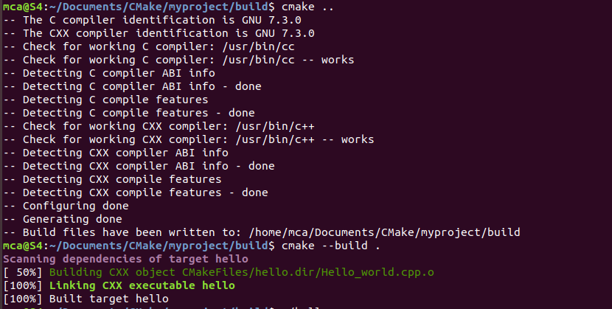

./hello: Run the executable by typing:

